**Project Development Phase Sprint 2**

|  |  |
| --- | --- |
| Team ID | PNT2022TMID13652 |
| Project Name | Smart waste management system for  metropolitan cities |
| Maximum Marks | 8 Marks |

Publishing Data to IBM cloud:

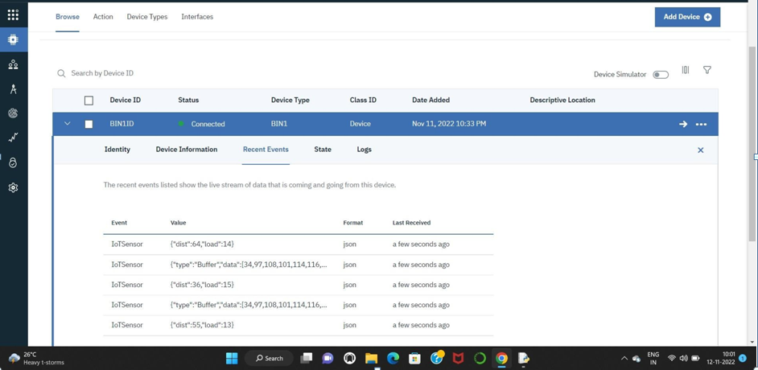

**CONCLUSION:**

In sprint 2, the data generated by the sensor in the IOT device is published into the IBM cloud which we can able to fetch the data anywhere in the world .The data will dynamically stored in the cloud, which is then retrieved for further future action.